**Tableau project.**

**Software used:** Tableau public 2023.2

**Data source:** Sample super store from Kaggle datasets

**Project Created by :** Ajinkya Shetye

**User story**

Store manager wants to know the over all sales and profit data for last 4 years and its trend.

1. Find total sales, profit, total units sold from 2014 to 2017
2. Find total no. of orders placed, state wise profit, profit of segment and shipping mode from 2014 to 2017.
3. Find products name which has highest and lowest number of profits selected by user. Also find sub category wise sales.
4. Find state wise customer details and compare trend of sales vs profit

Dashboard 1

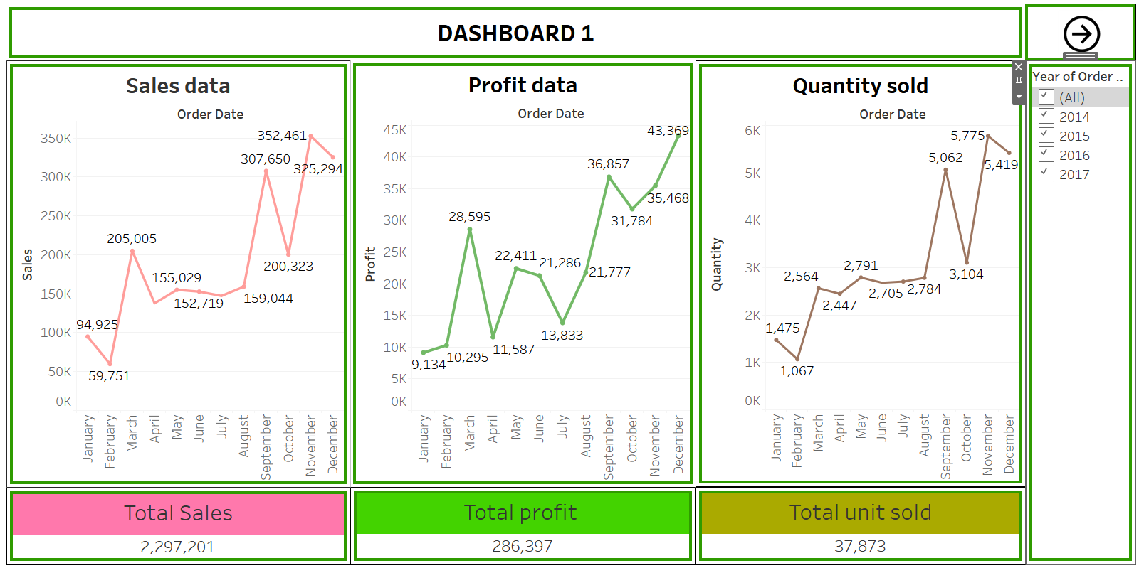

* Total three graphs are available sales, profit, quantity sold vs order date
* On right side of dashboard user can select year of order.
* User can select specific year and see all data as per the requirement
* KPI values shows year data and graph shows trend from January to December. If user select specific year for eg 2014 whole dashboard will show 2014 data only.
* If user wants to check month wise sales, profit, quantity sold then just hover mouse on month name of sales data(graph) data will change according to month.
* User can select one or many years simultaneously.
* Up right corner of dashboard there is right arrow button, click on it and second dashboard will appeare.

Dashboard 2

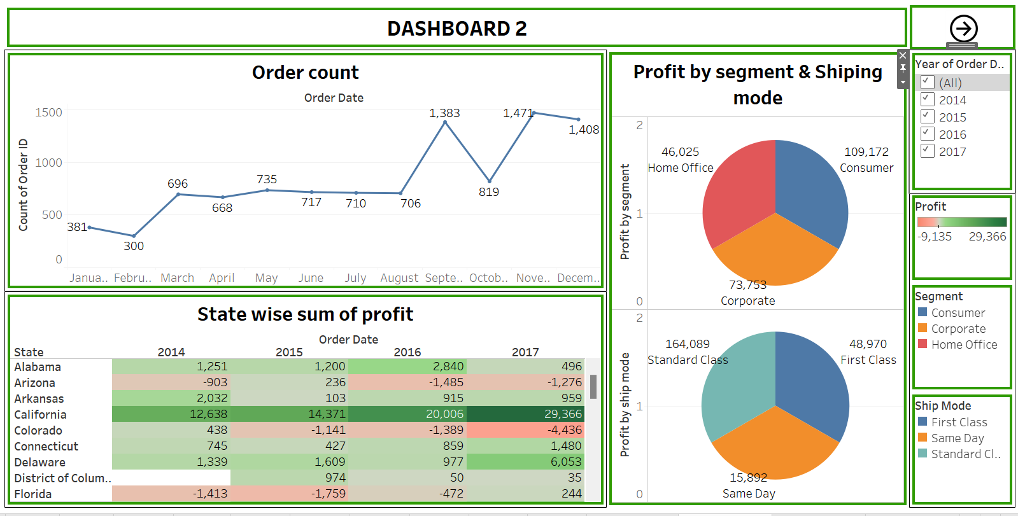

* We have total three datasheet in dashboard 2, count of order ID in line graph, state wise sum of profit in tree map, profit in segment and shipping mode in pie chart.
* **State wise sum of profit-** It shows profit of states in each year with dark green showing maximum profit and red showing loss.
* **profit in segment –** it shows overall profit in segment wise i.e home office, consumer, corporate.
* **Profit by shipping mode-** it shows overall profit in shipping mode i.e Standard class, first class, same day.
* **Order count-** User will able to see total number of order placed from January to December. User can also change year with (year of order) data section present on right side of dashboard. Year of order date is only applycable to order count only.
  + If we hover mouse on months of order count then State wise sum of profit will show month wise profit and profit in segment/ shipping mode will show aggregate profit of month from every year.

Dashboard 3

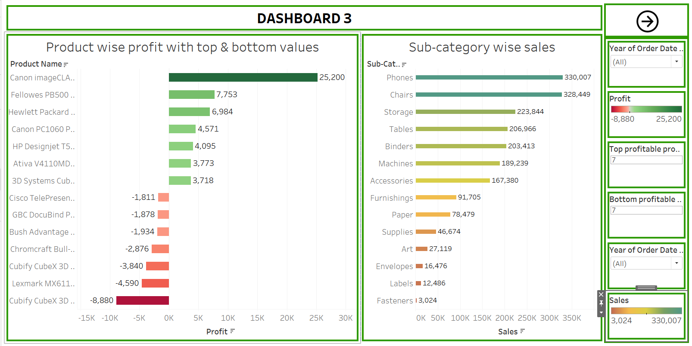

* We have two graph in dashboard 3 i.e both are bar graph showing product wise profit and sub category wise sales.
* **Sub-category wise sales**- it shows over all sales in sub-category for each year as well as all year combined with help of year of order date subcategory (drop down) present on right side of dashboard.
  + Maximum sales is shown in light green bar and minimum sale is shown in orange bar.
* **product wise profit-** it will show highest and lowest profit and user can select how many number of highest and lowest profitable product to be shown by using top profitable product and bottom profitable product.
  + It shows profit of each year as well as all year combined with help of year of order date product name present on right side of dashboard.
  + Maximum profit is shown in dark green bar and maximum negative profit is shown in dark red bar.

Dashboard 4

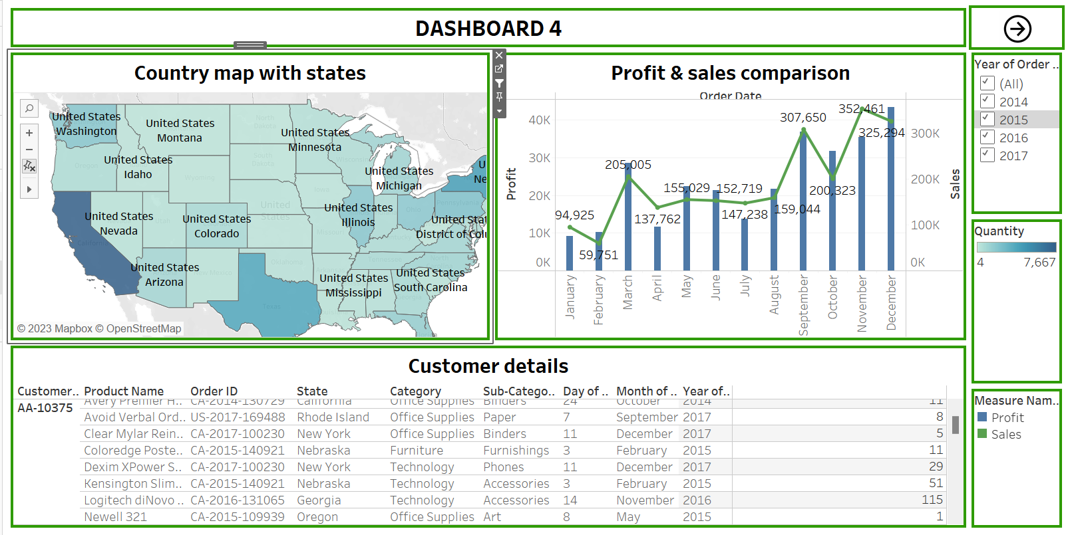

* Dashboard 4 shows country map with states, profit & sales comparison and customer details.
* **profit & sales comparison-**This is line and bar chart which shows profit and sales of each year

and all year combined using year of order menue present on right side of dashboard.

* Green line shows profit and blue bar shows sales in this chart.
* **Customer details-** It has all customer details.
* **Country map with states-** Country map has all states clicking on any state will show customer details and profit & sales comparison chart of that state.
* We can also change year for specific state of profit & sales comparison chart only but not for customer details. Customer details will show all data from every year.
* Dark blue colour in state shows maximum quantity purchased and light blue shows minimum quantity purchased.